Hi Friends,
In this document, I am going to provide the step by step user manual for creating Service Purchase Requisition. This document is prepared to make it useful for beginners for Service Procurement

Find below step by step process:

- Create Service Purchase Requisition

Transaction Code: ME51N

Navigation: Logistics->Materials Management ->Purchasing ->Purchase Requisition ->ME51N - Create

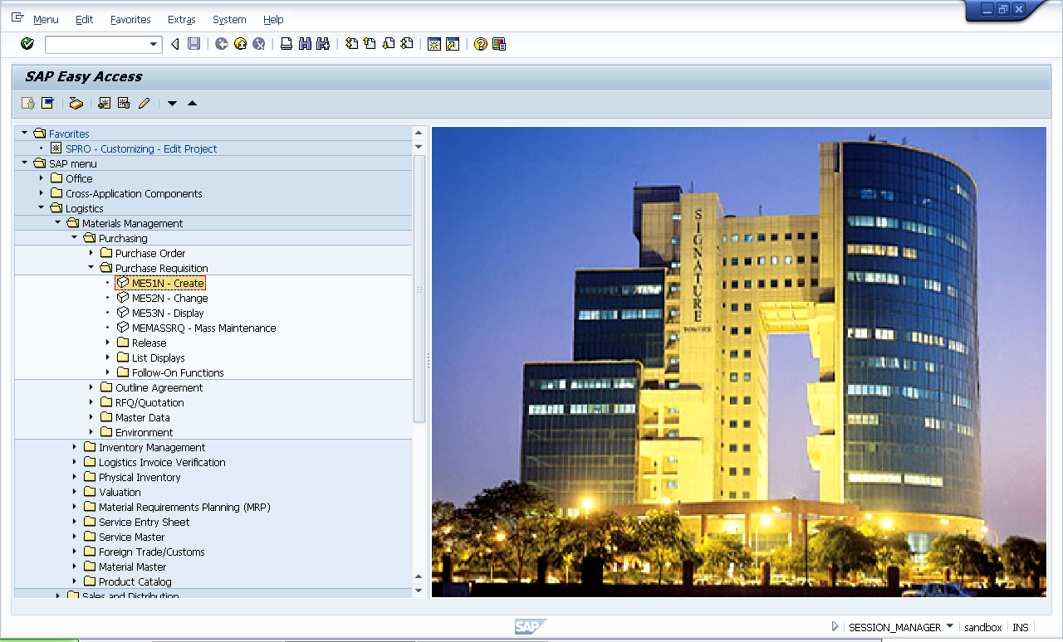
Or Double Click
On ME51N

Input ME51N in Transaction Bar

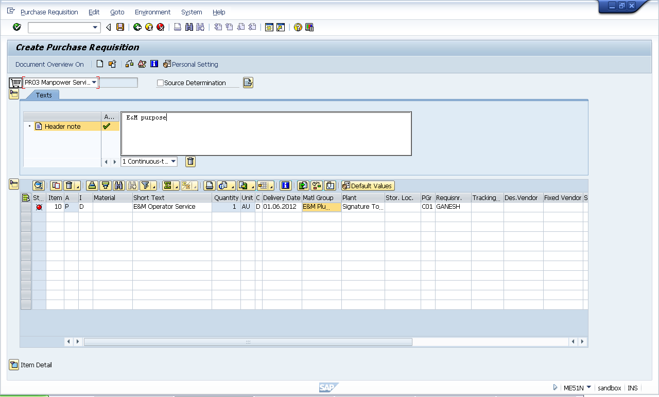
8. Enter Pur. Group

2. Input Indent Purpose

5. Enter Short text of SC purpose

3. Enter A/c assignment as ‘P”

6. Enter Mat. Group

4. Enter Item category as “D”

1. Select PR Type PR03

7. Enter Plant

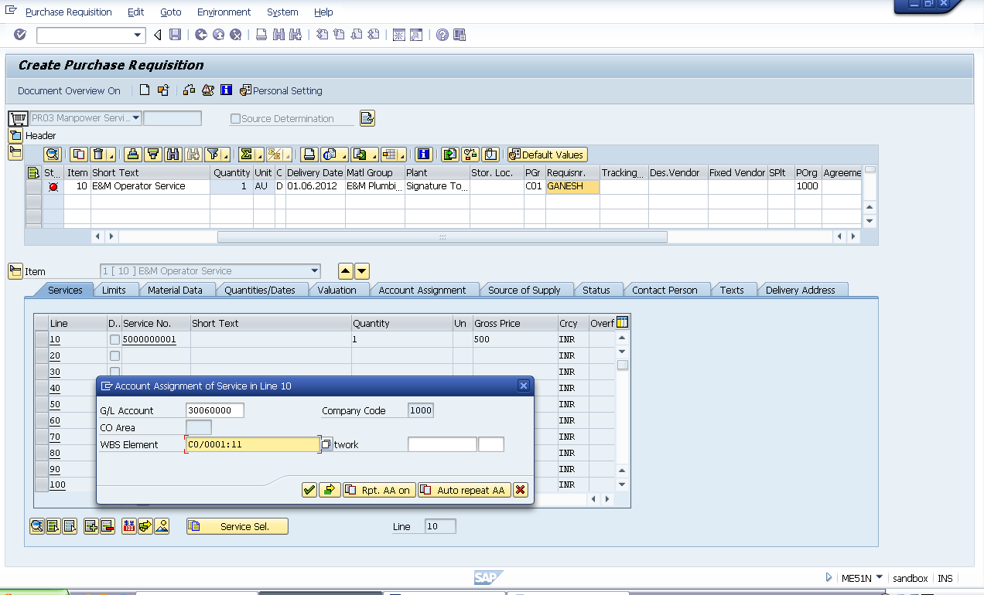
9. Enter Pur. Organization

11. Enter Service Qty

12. Enter Gross Price

13. Enter WBS Element

10. Enter Service No.

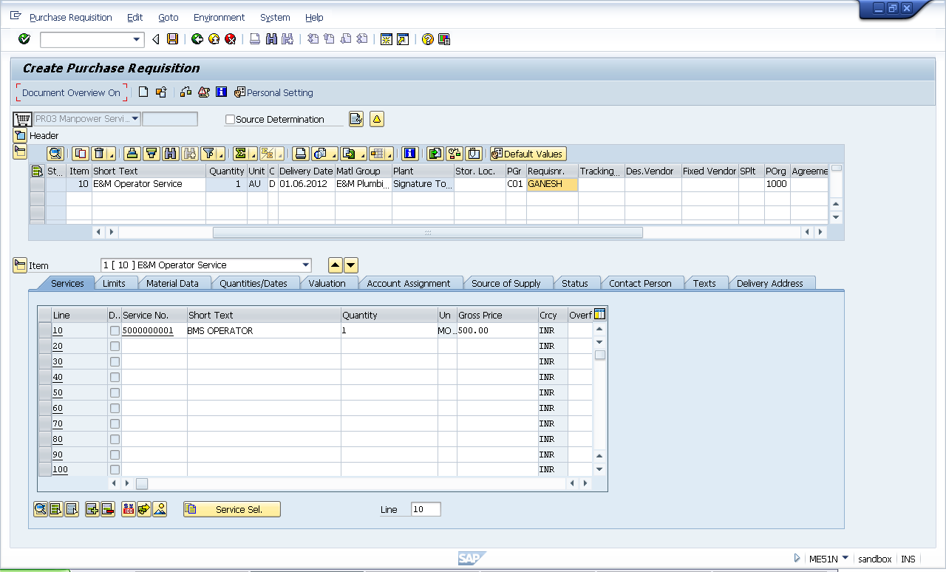
14. Click on check

15. Click on save

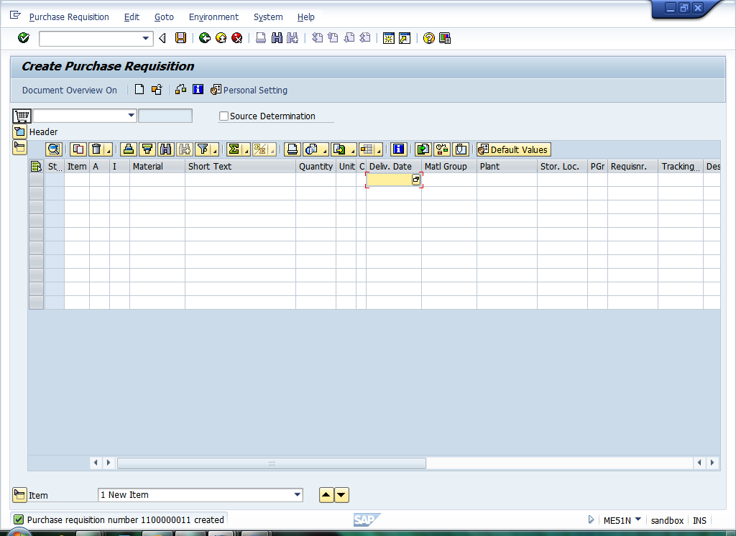
16. Following Message is shown

Thanks for referring this document. Share with your colleagues and friends and make this document more useful. And also your feedback will be useful for me to update few more documents

Best Regards,
Ganesh

