Physical Inventory Verification | MI01

Purpose
This transaction code is used for Creating Physical Inventory Document

Prerequisites

Menu Path
Use the following menu path(s) to begin this transaction:
Logistics
--> Materials Management
--> Physical Inventory
--> Physical Inventory Document
--> Create

Transaction Code
MI01, MI21, MI04, MI20, MI07

Helpful Hints
- Press F1 for help
- Press F4 for getting input values
- Click to go to previous screen.
- Click to go to Exit the transaction or to log off.
- Click to go to cancel the transaction.

Procedure
Create Physical Inventory Document:

Transaction Access Path
Required User Input
Click where shown
Logistics
--> Materials Management
--> Physical Inventory
--> Physical Inventory Document
--> Create
Alternatively, you can access the transaction directly via transaction code: MI01

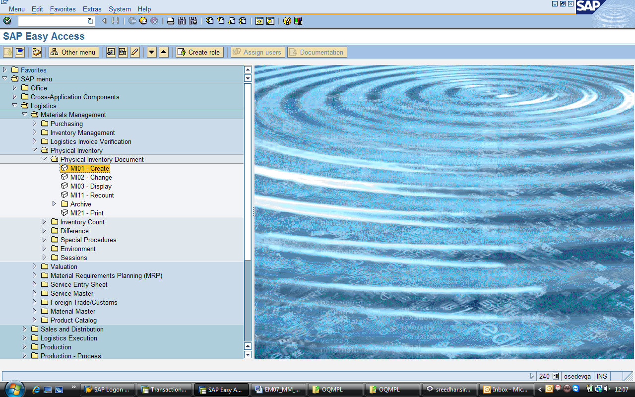

Double click on MI01

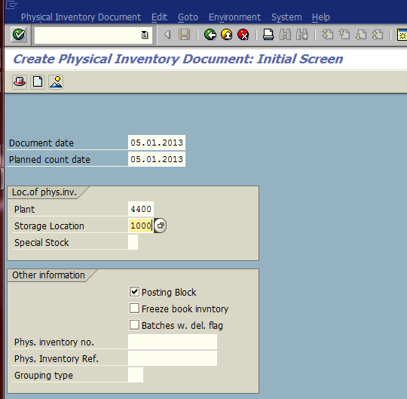
3. Check Posting Block
2 Enter storage location &press Enter
1 Enter Plant

Enter Plant No & Storage location no where you need to take Physical Inventory & press “Enter “key on key board.

Enter Material codes of identified items in storage location (To identify material code use MB52 transaction with identified storage location), after entering material codes, then press enter key, then you can further enter material codes.

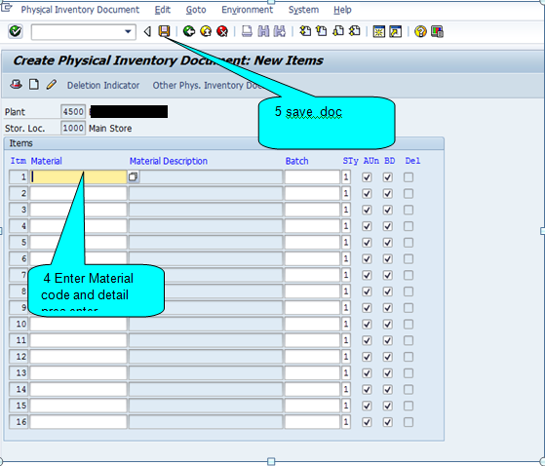
4 Enter Material code and detail pres enter
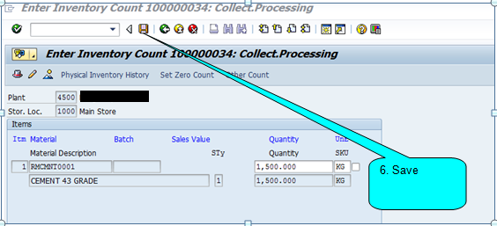

Come back & with T.Code - MI21 take Print out physical Inv. Document.
Hand over print out to person who will be taking physical inventory.
It is recommended to take Physical inventory on the same day and update Inventory count & post it after approval.

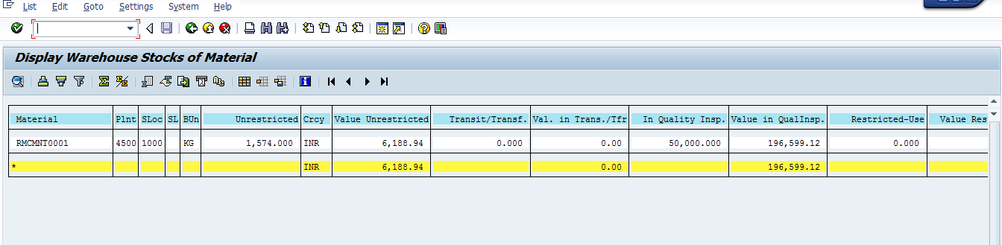

Process: Physical Inventory Count

Go to T. Code – MI04 – Inventory count
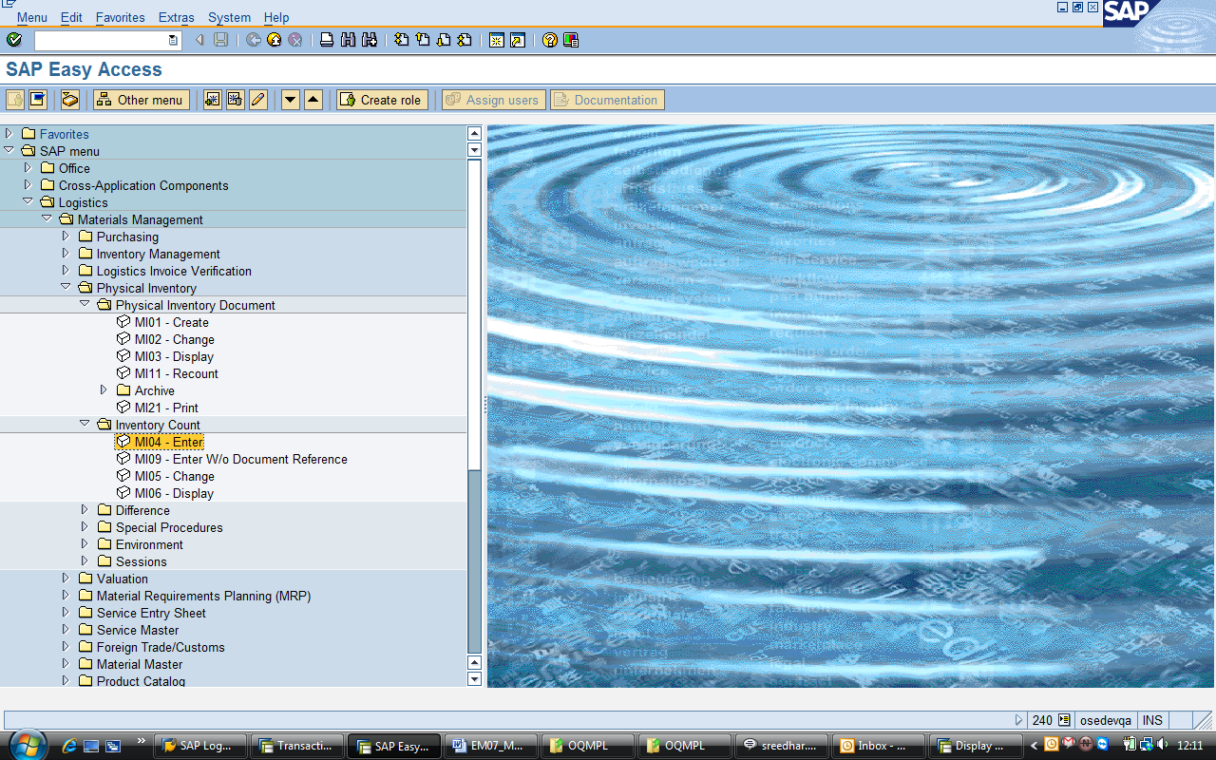

Enter Physical Inventory document number for which you wish to update “Physical qty “counted” & press “Enter ‘key on key board. Please note that with this transaction, system understands what the physical quantity against each item is. However with this transaction it does not update / post physical qty. Also after this transaction system allows comparison between book stock & physical stock.

Please enter physical qty counted of each item. In case physical qty is “Zero” then please tick in “ZC” – Zero count – button against respective item.

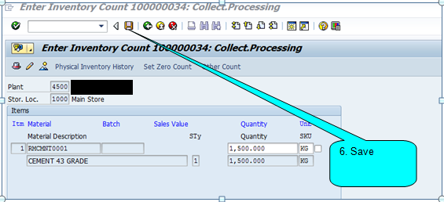

For example in below example stock item code 21000001 is Zero. 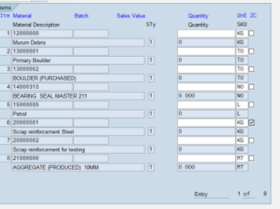
Enter Inventory count
After entering Physical count, press on SAVE button.

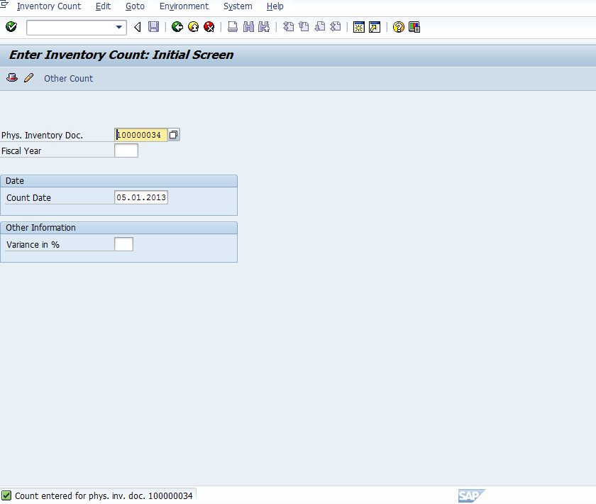
7 Message will be displayed as below

Process: Physical Difference Posting

Go to T. Code – MI07 to post difference.

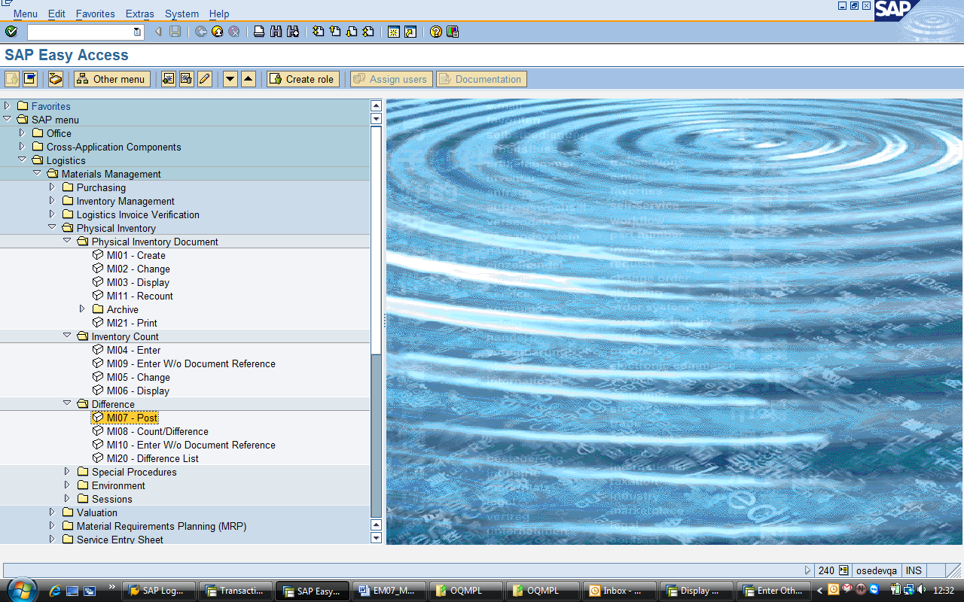

Enter Physical Inventory document number & Press Enter

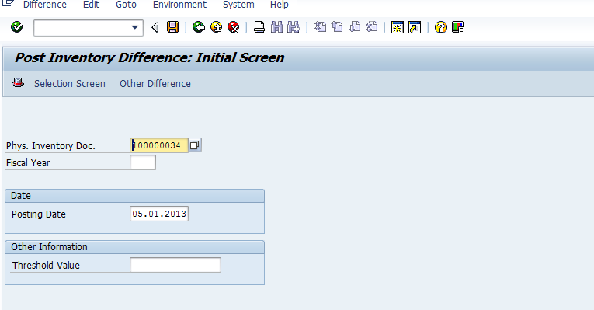
8 enter doc no & execute the process

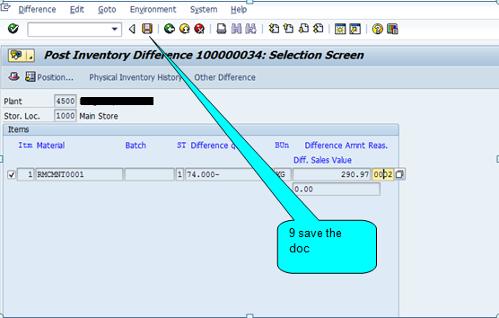

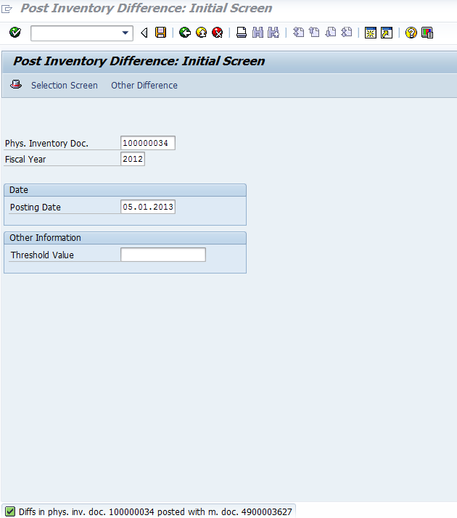

10 The message with document number will be displayed

Click on SAVE button.
With this physical stock will get updated.
After this if you view stock with T. Code MB52, physical stock will appear in the same.

Again take print out with T. Code – MI21 and provide to person who will take physical stock again.
Thanks for referring this document. Share with your colleagues and friends and make this document more useful. And also your feedback will be useful for me to update few more documents

Best Regards,
Ganesh

