Evaluated Receipt Settlement

Procedure for settling goods receipts automatically. When you use Evaluated Receipt Settlement (ERS), you agree with the vendor that the latter will not submit an invoice in respect of a purchase order transaction. Instead, the system posts the invoice document automatically on the basis of the data in the purchase order and goods receipts. This eliminates invoice variances.

Advantages:
ERS has the following advantages over the Logistics Invoice Verification done by MIRO:
- Purchasing transactions are closed more quickly.
- Communication errors are avoided.
- There are no price and quantity variances in Invoice Verification.

It is recommended to implement ERS only if a clear agreement exists with the vendor on the applicable conditions. The purchase order has to be updated for any price condition changes and has to be current.

Settings for Evaluated Receipt Settlement:

Configuration Settings:
There is a legal requirement for the companies in France and Spain to have Consecutive number for each vendor invoices which can be achieved by the customizing setting here. The number range groups are created here and assign this number range group to tax number 3 field in Vendor Master Record.

Define the Message type:
The message type ERS is set up in the configuration through below path
SPRO -> IMG -> Material Management -> Logistics Invoice Verification -> Message determination -> Maintain Message Types

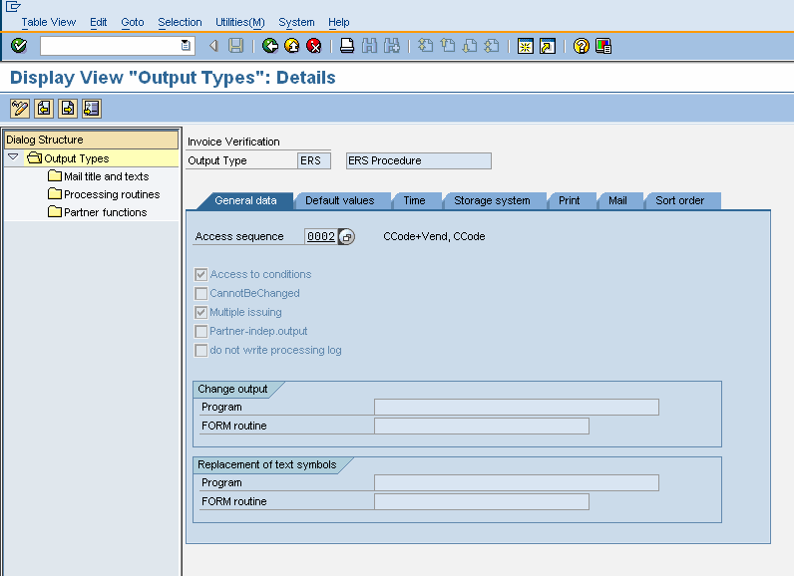

Required access sequence is maintained in the message type.

- Maintain Message Schemas:
Maintain the message type (ERS) in the message Schemas MR0004 – ERS Procedure in the following IMG path
SPRO -> IMG -> Material Management -> Logistics Invoice Verification -> Message determination -> Maintain Message Schemas

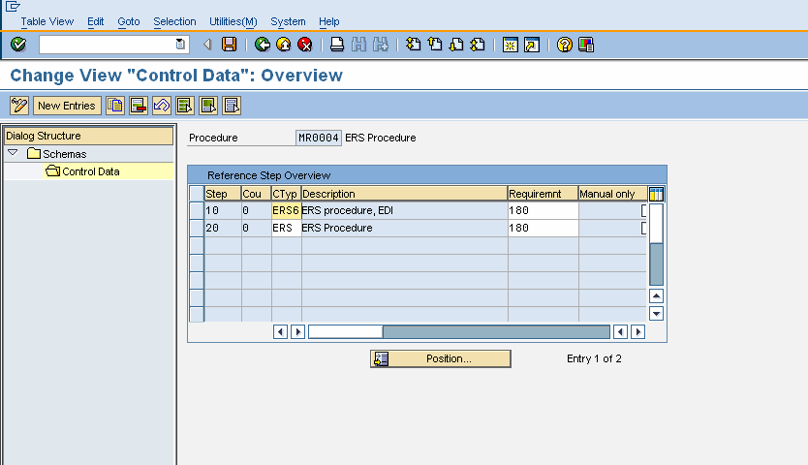

- Maintain Conditions:
Create the condition record for the message type ERS in the following IMG path
SPRO -> IMG -> Material Management -> Logistics Invoice Verification -> Message determination -> Maintain Conditions (Transaction code – MRM1)

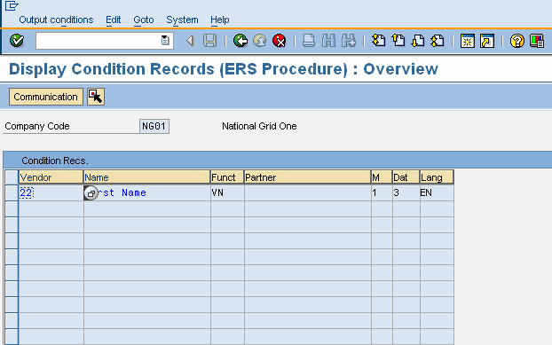

Prerequisites:
- Vendor Master:
In the vendor master purchasing data, the relevant settings for ERS has to be maintained.

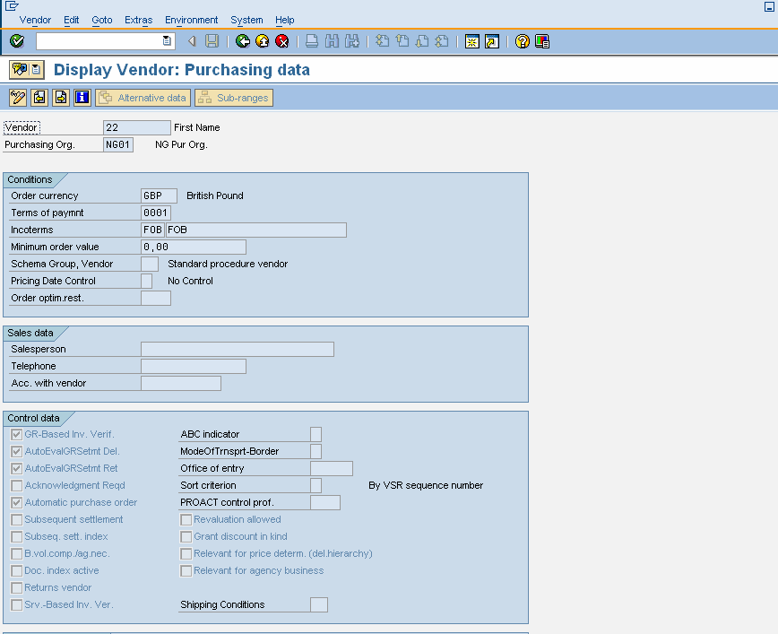

GR-Based Inv Verification: Indicator specifying that provision has been made for goods-receipt-based invoice verification for a purchase order item or invoice item.
Auto Eval GR Settlement Delivery: specifies that evaluated receipt settlement or the automatic generation of the invoices are allowed in relation to materials supplied or services performed
Auto Eval GR Settlement Return: Specifies that automatic evaluated receipt settlement of return items is allowed.

- Purchase Info Record:
Ensure that No ERS indicator is not checked in the info record for the Material + Vendor + Plant + Purchase organization. This field can be potentially used to disallow the ERS for the specific combination of Material, Vendor, Plant and Purchase Organization. The indicator GR- Based IV defaults from the Vendor Master

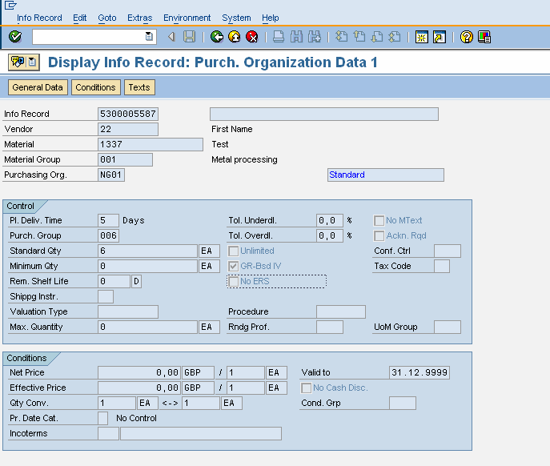

- Purchase Order:
  - GR-Based IV and ERS are defaulted from Vendor Master and Purchase Info record. Ensure that the above settings are maintained in the Purchase order.
  - Tax code must be maintained in the purchase order so that auto settlement considers this tax code.

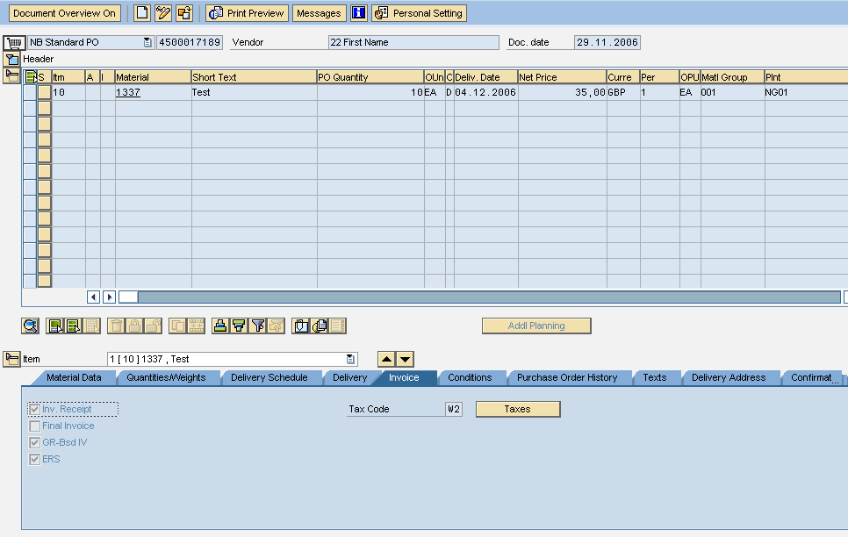

Note:

If you flag a vendor as being subject to ERS, the system sets the ERS indicator as a default in each item when you create a purchase order for the vendor. You can prevent this happening for certain vendors by flagging the info record for the material and the vendor as not being subject to ERS.
In Purchasing, you can delete the default ERS indicator in a purchase order item.

- Process Flow:
Evaluated Receipt Settlement (ERS) process posts the invoice documents for all open goods receipts without expecting the invoice from the vendor.
The Process can be run using the transaction code MRRL. The important key fields are available for document selection like Company code, Plant, Vendor, Purchasing Document number etc.

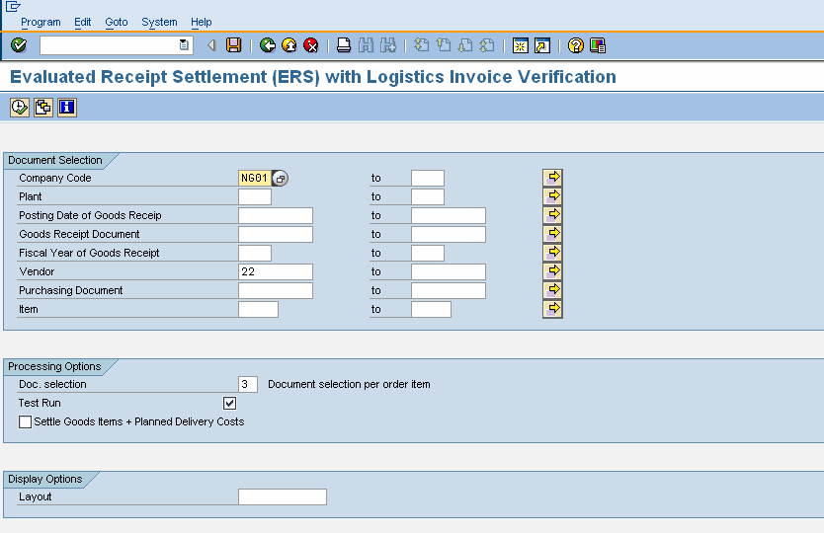

The Simulation is also possible by test run so that the goods receipts which can be posted are listed and also the documents which cannot be posted are also listed. At this point, the system makes no postings and only goods receipt documents are listed

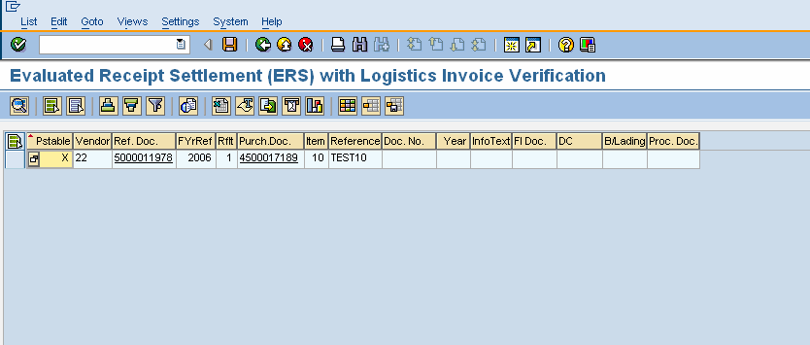

After simulation run, the transaction can be executed to settle the documents by un-checking the test run indicator. Generally ERS is run through batch job as it doesn’t need any manual changes. The Background job also can be scheduled with the program RMMR1MRS to settle the documents periodically.

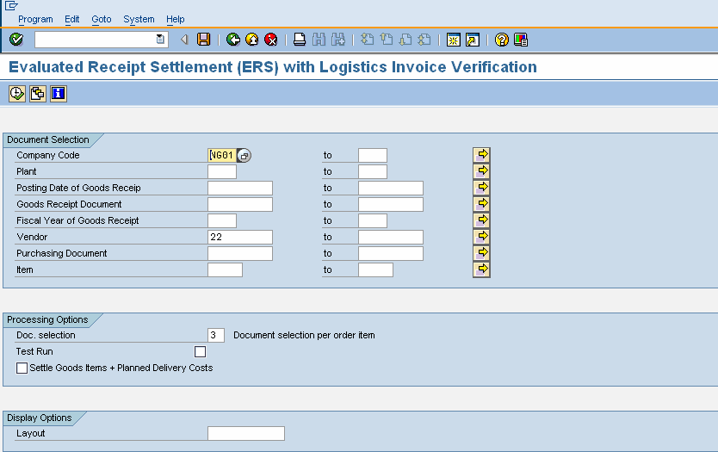

The invoice document is generated for the particular vendor which is specified in the selection screen and is listed. During the ERS settlement, the message is generated. The message can be transmitted to the vendor based on the business requirement.

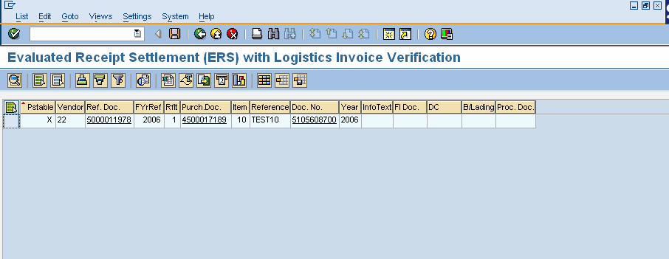

Thanks for viewing the document. Share the blog with your friends.

Regards,
Ganesh

