Create & Post Down Payment Request | ME2DP

Purpose
This transaction code is used for creating & Posting Down Payment Request. Down Payment usually pays to vendor after PO creation as per the agreement with vendor.

Prerequisites
- Down Payment in Purchase Order. Down Payment details have to be given in PO Header (Payment Processing Tab) or PO Item (Invoice Tab).

Menu Path
We can directly access the transaction by typing t-code in command field: ME2DP

Transaction Code
ME2DP

Helpful Hints
- Press F1 for help
- Press F4 for getting input values
- Click to go to previous screen.
- Click to go to Exit the transaction or to log off.
- Click to go to cancel the transaction.

Procedure
CREATE & POST DOWN PAYMENT REQUEST

We can directly access the transaction by typing t-code in command field: ME2DP

Initial Screen:
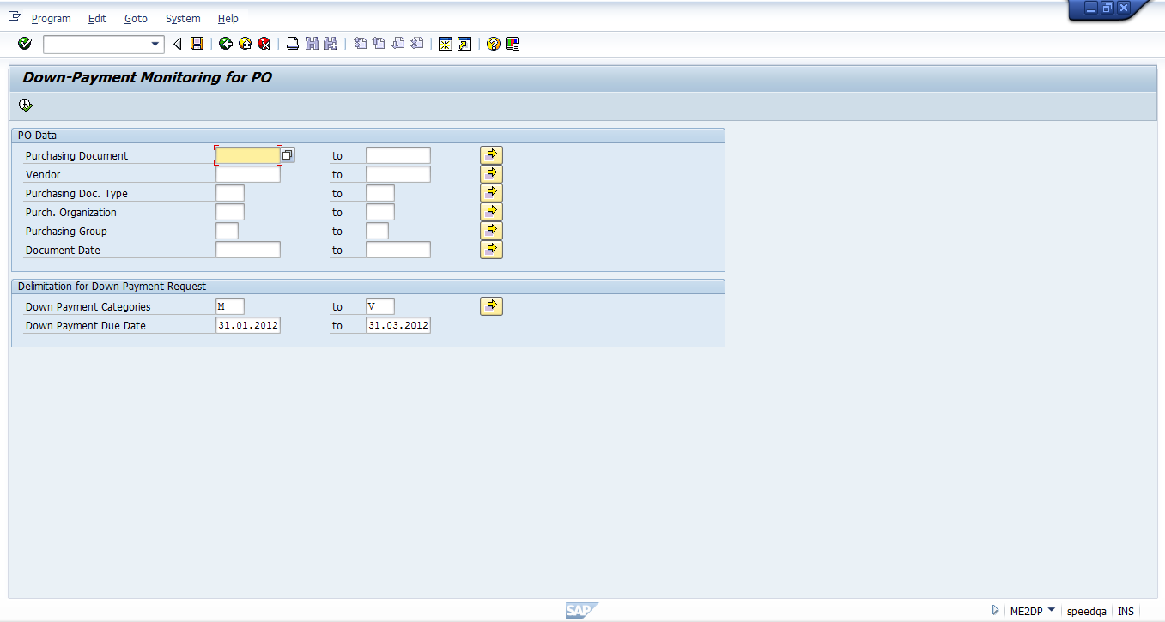

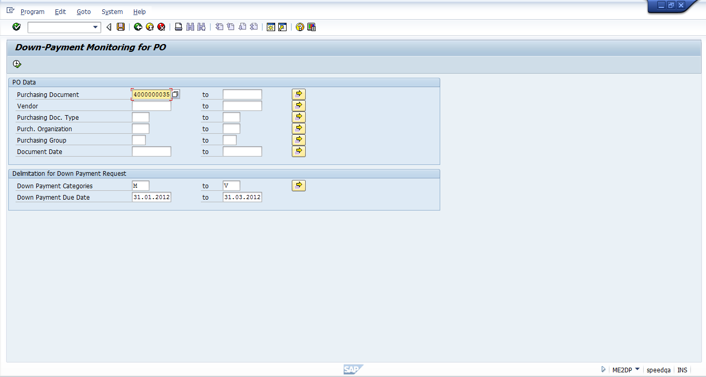
2. Press Execute

1. Enter Purchase Order Number:

We will be redirected to following screen:

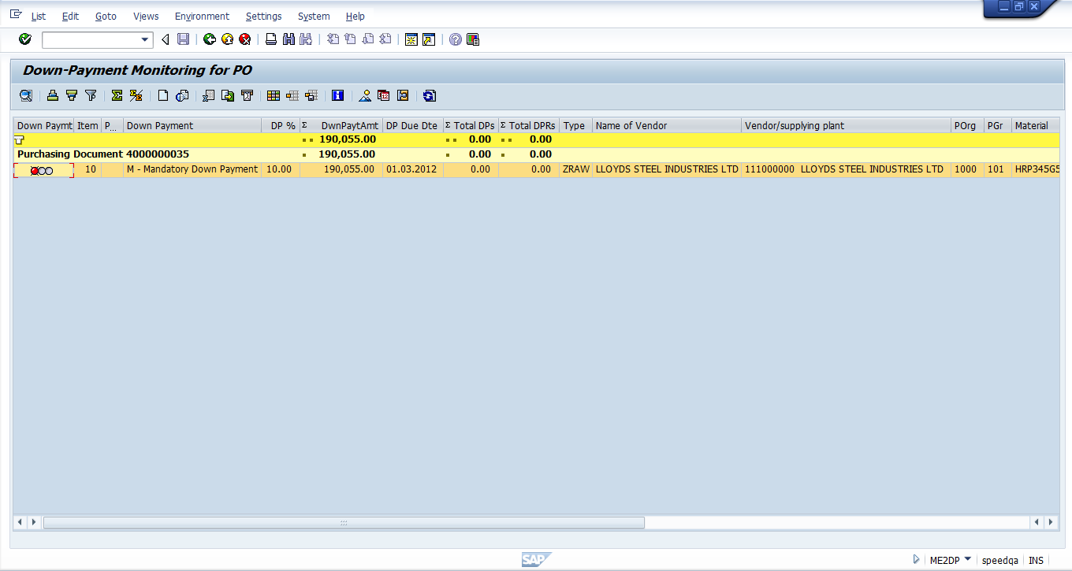
3. Select Line Item: press enter
:

After pressing enter following screen will be appeared: 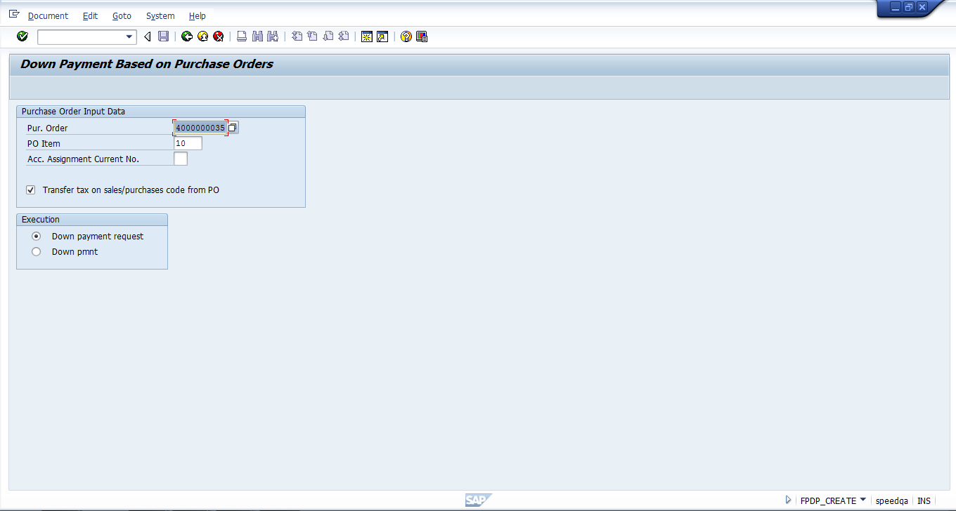
4 enter PO No &enter

5 click on radio button

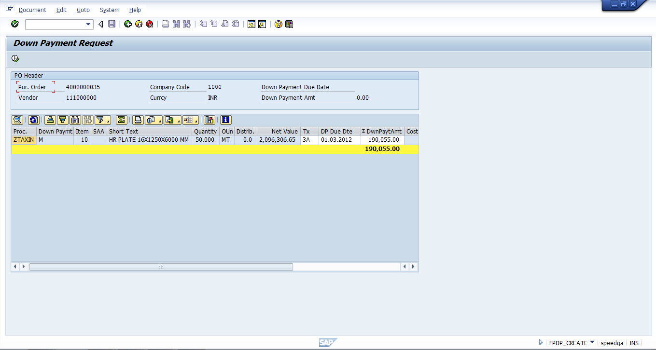
6 click on Execute
:

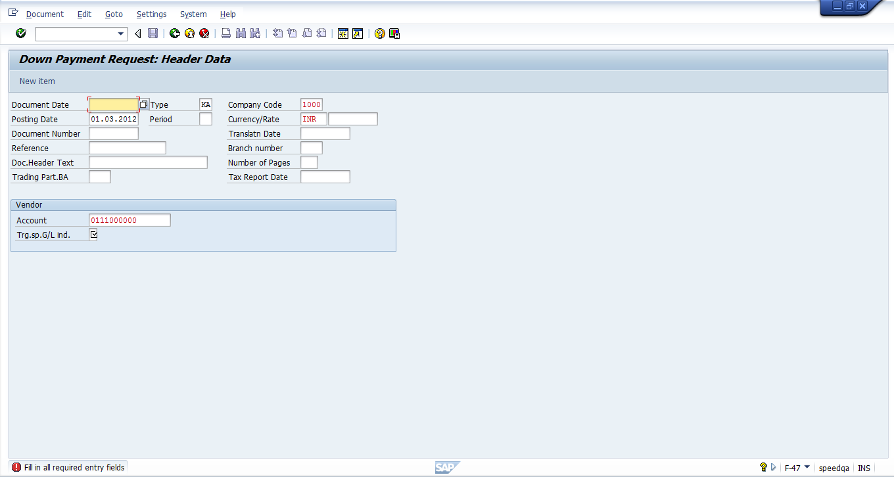
8. Set the indicator
:

Double Click on option A- Down Payments & current Asset:
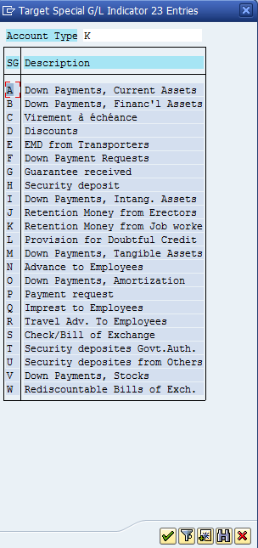
9 Double Click on Down Payments & current Asset
:

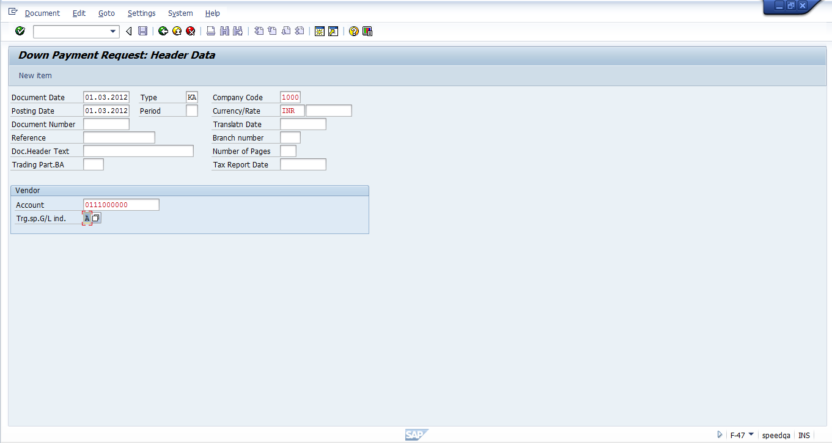
10 Press Enter

Pressing Enter will lead to following screen:

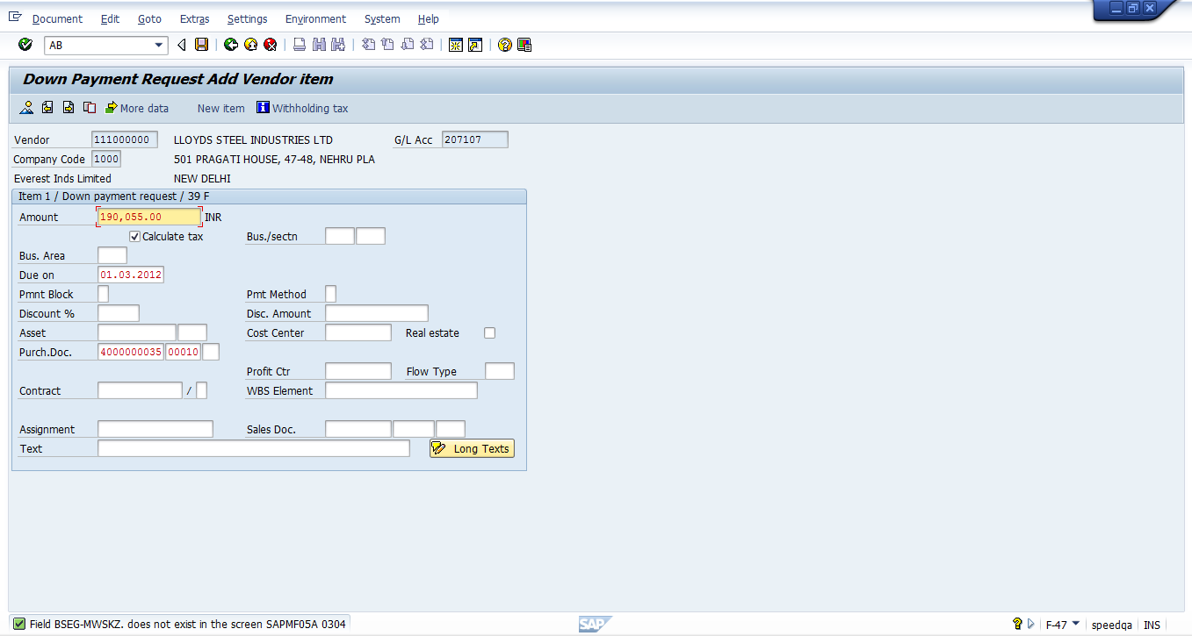
Press Enter:
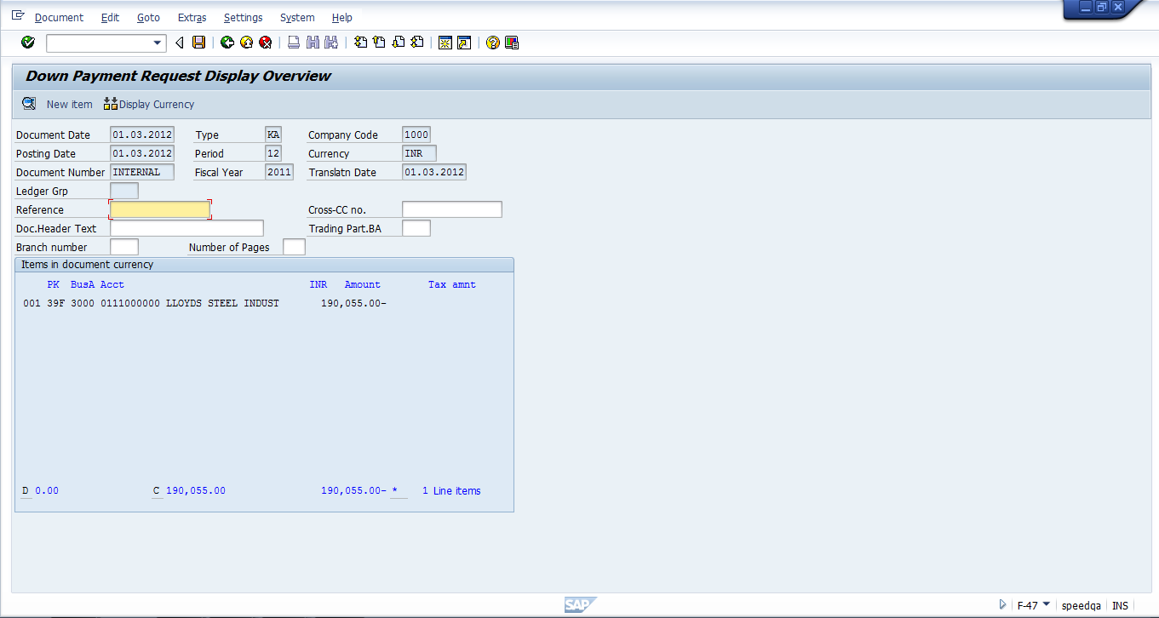
11 Enter reference doc no
12 Save doc
Enter Reference And Save Document as shown above.

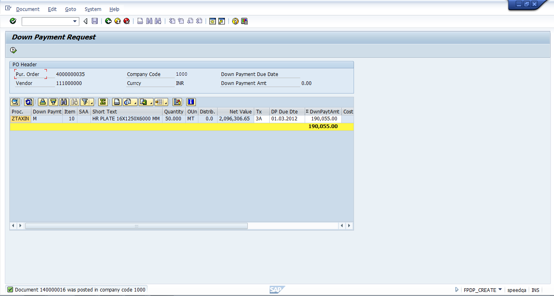
For Posting Down Payment Request:
T-Code ME2DP
Initial Screen: Enter Purchase Order Number:
2. Press Execute
1 Enter PO no

Following screen will be appeared:
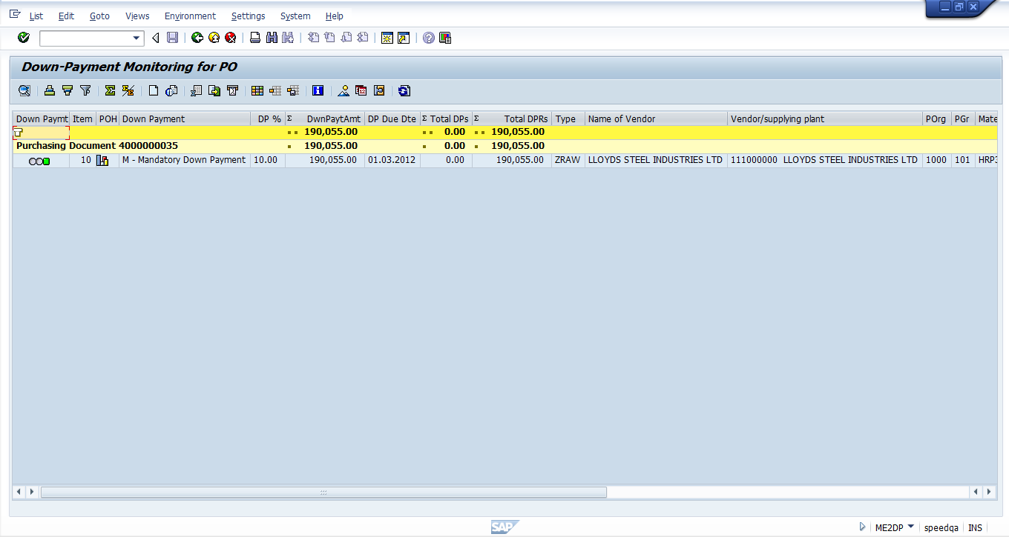

Select Line Item:
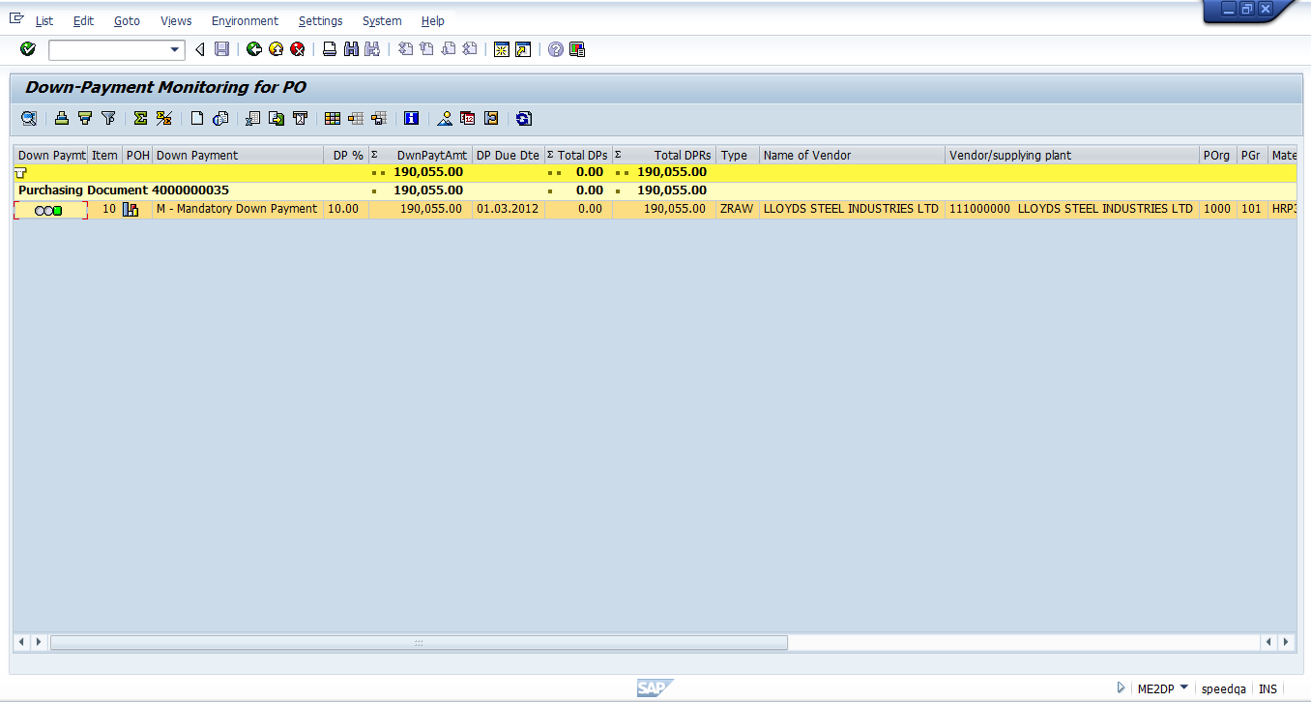
3 Select the line Item

Pressing enter will lead to following screen:
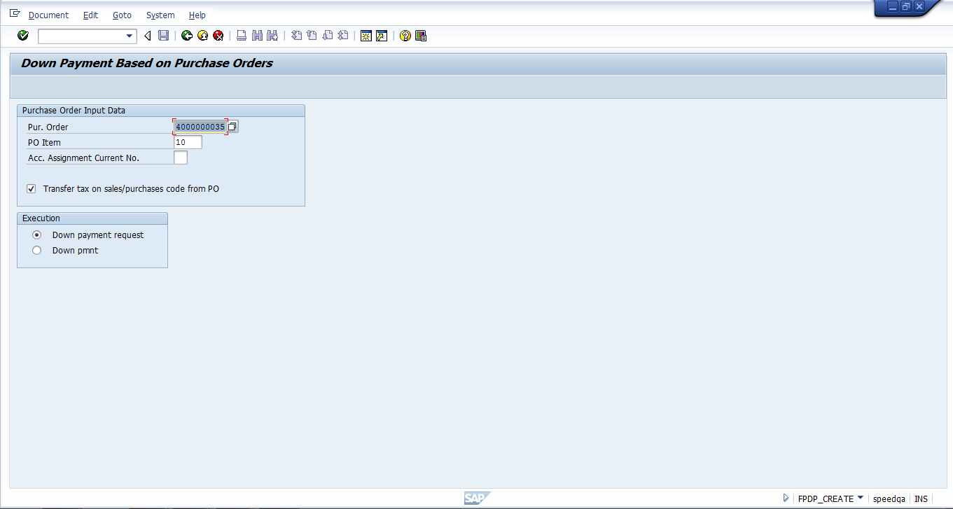
4 Select the radio button

Select Down Payment:

Pressing enter will lead to following screen:
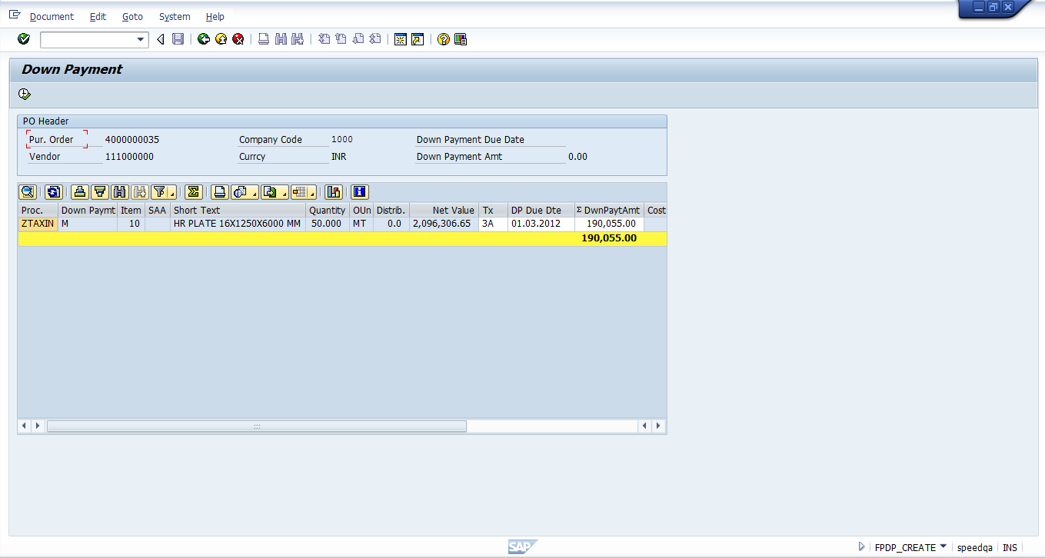
5 press Execute
Below screen will be appeared after pressing Execute
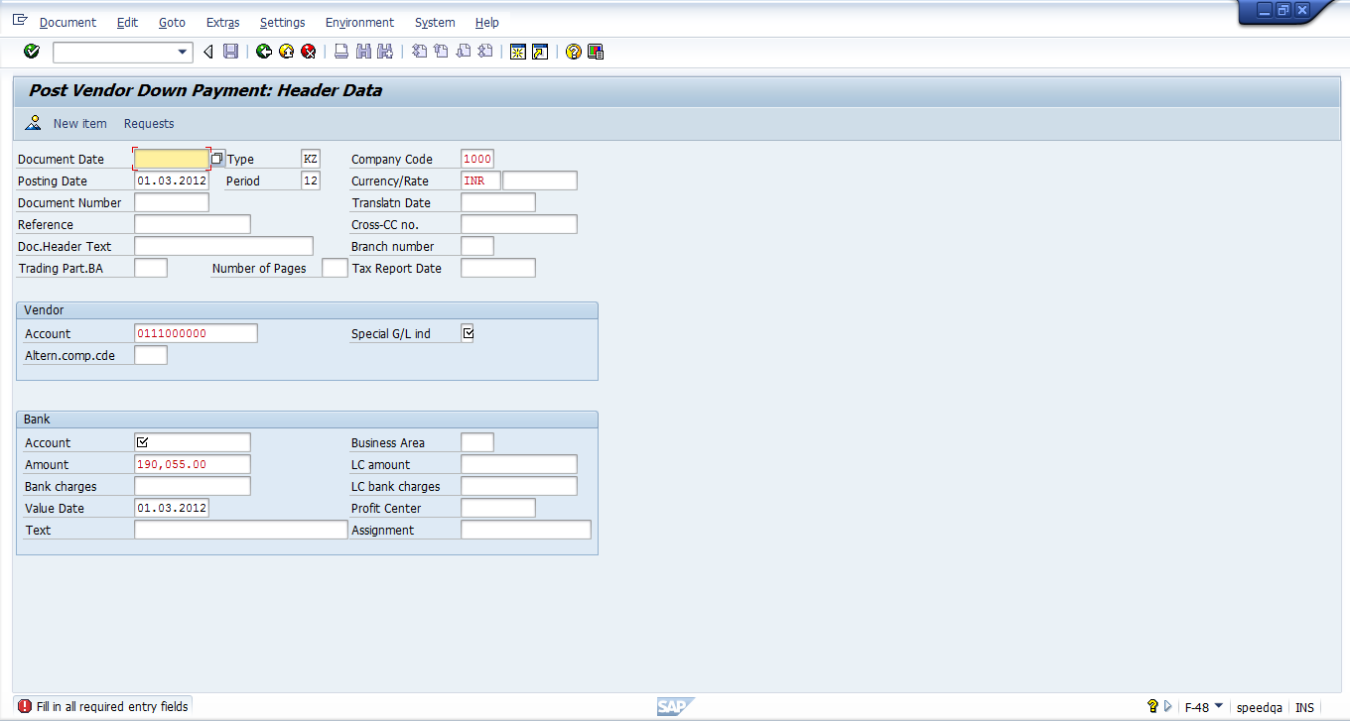
7 Select the account
6 Enter Doc Date

Press F4 in Account:

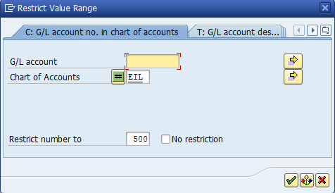

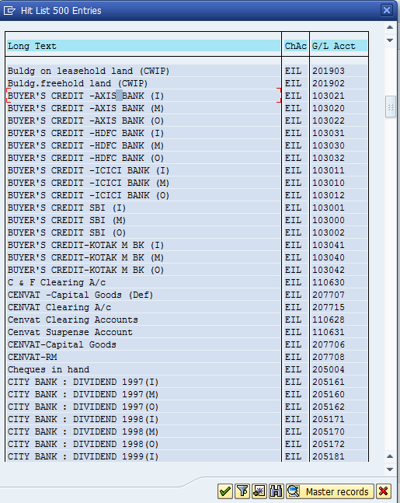

After Double clicking following screen will appear
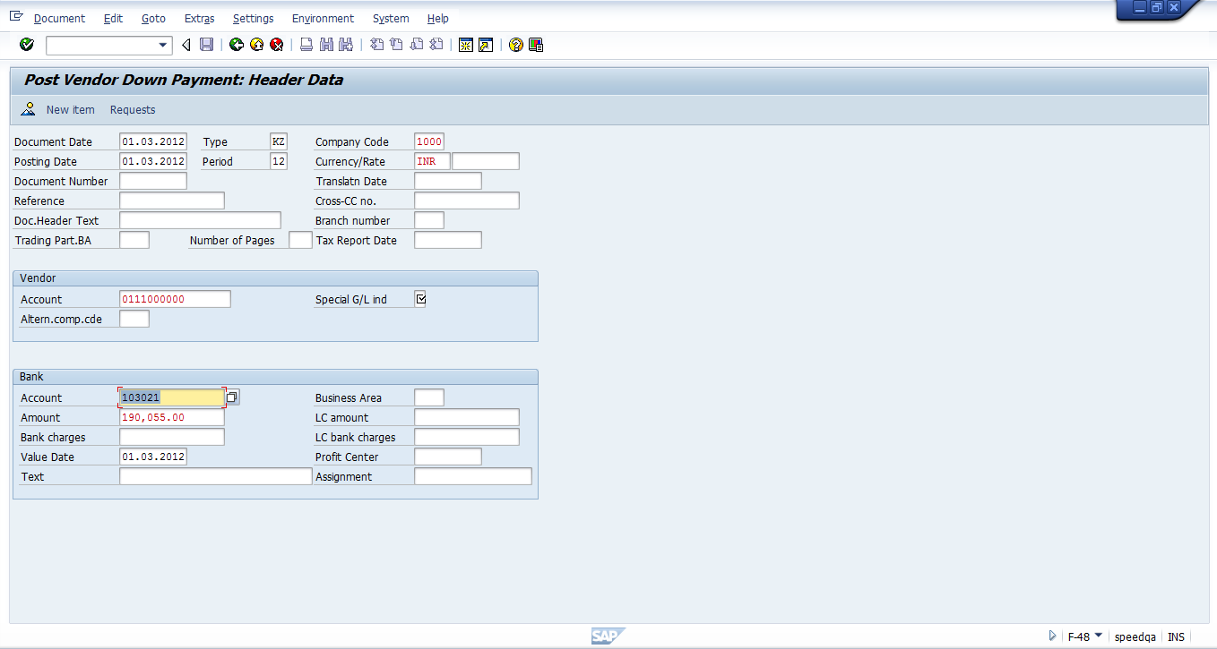
8 select special GL
Now select Special G/L indicator:

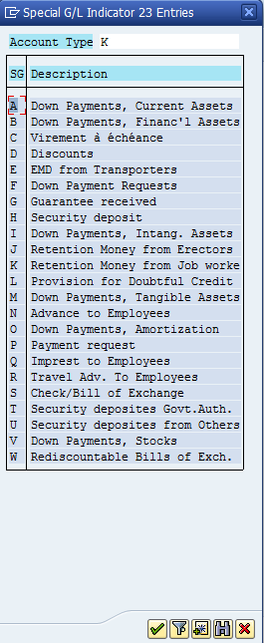
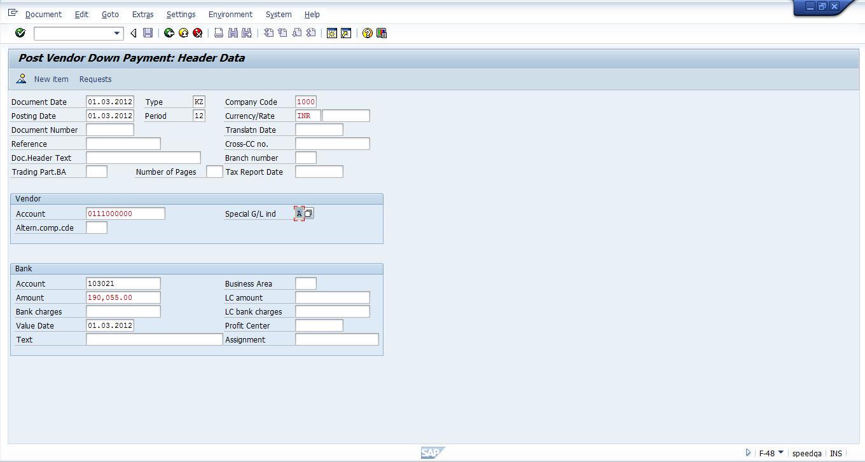

Press Enter and Save Document:
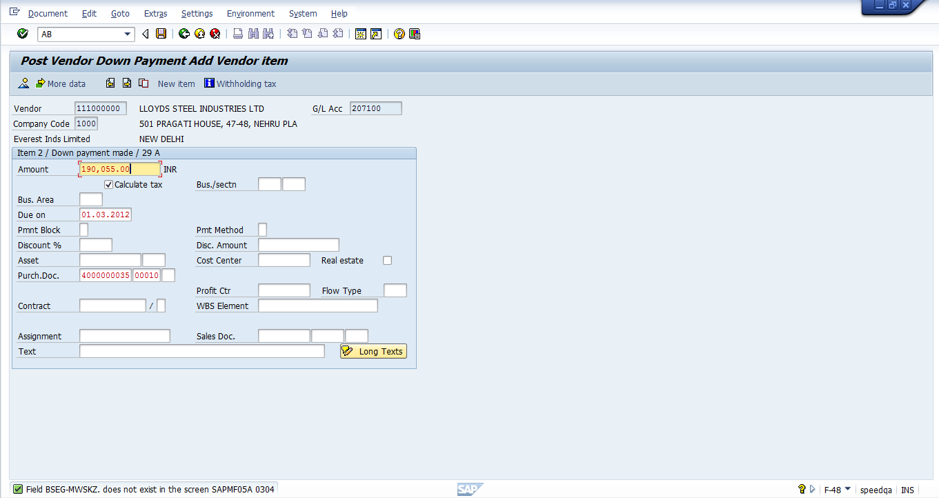
9 save the document

Down Payment Request is now posted:

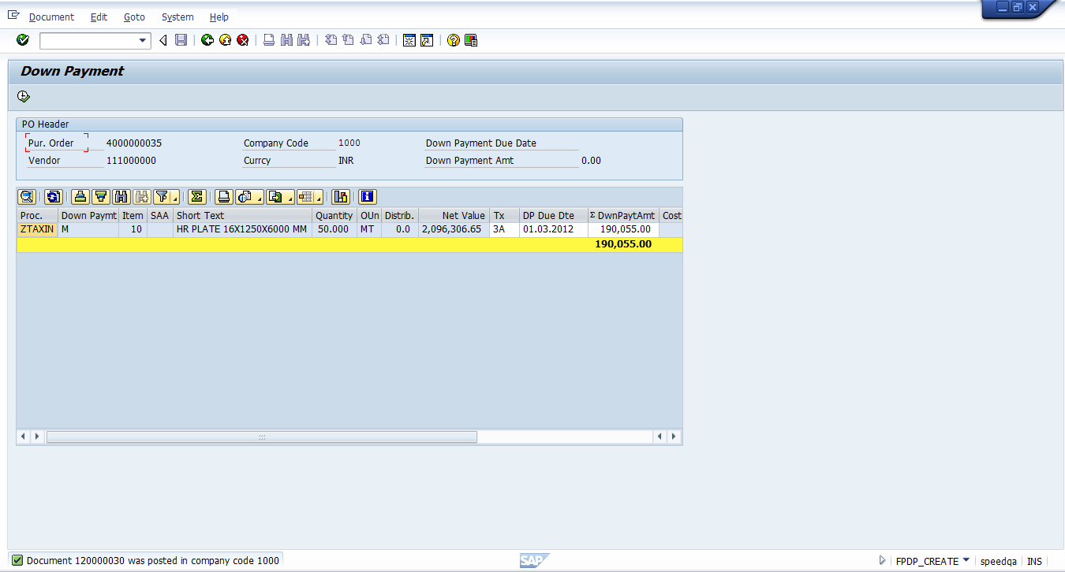
10 Message will display

Thanks for referring this document. Share with your colleagues and friends and make this document more useful. And also your feedback will be useful for me to update few more documents

Best Regards,
Ganesh

